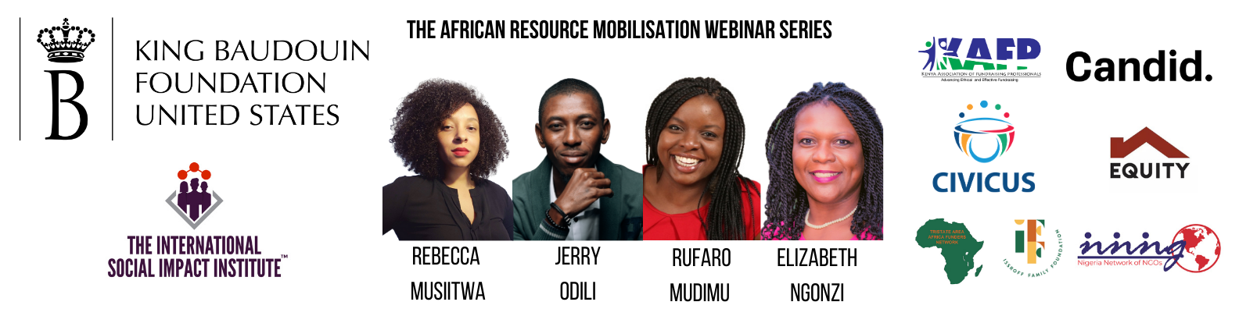
The African Resource Mobilisation Webinar Series:
Fellowships, Awards, and Honours Information

From Speakers:

Rebecca Musiitwa - The Obama Foundation

The Obama Foundation’s Leaders: Africa Program
The Obama Foundation’s Leaders programs aim to inspire, empower, and connect regional cohorts of changemakers to accelerate positive and lasting change in their communities and throughout their region.
Through an individual and collective leadership development journey, Leaders will grow in the dimensions of our values-based leadership philosophy, inspired by President and Mrs. Obama and rooted in promoting equity and inclusion. Core to the Leaders experience is practicing self-reflection, building a strong regional community of peer learning, collectively developing grassroots solutions, and supporting other emerging leaders globally.

Upon completion of the program, Leaders will have gained a deeper understanding of how values-based leadership advances their ability to enact change. Leaders will be inspired to take further action, propelled by new ideas and skills. They will continue to gain a broader continental and global perspective, having built a larger community of changemakers that enables them to collaborate across regions and issue areas to accelerate their own work.

The Leaders program launched in Africa in 2018, expanded to Asia-Pacific in 2019, and inaugurated a Europe program in 2020. To date, Leaders: Africa has graduated two cohorts and has built a pan-African community of nearly 400 alumni, hailing from 46 nations, who are actively accelerating change across the continent.

Jerry Odili - Tech ME

Cordes Fellowship
Provides annual scholarships for 50 of the world’s most promising emerging social entrepreneurs to participate as full delegates in the Opportunity Collaboration (OC), an annual gathering in Mexico of 400+ global leaders building sustainable solutions to poverty and injustice.

Atlas Corps
Atlas Corps is an international network of social sector leaders between 18 -35 years old and organizations that promotes innovation, cooperation, and solutions to address the world’s 21st-century challenges.

StartingBloc Fellowship
Leadership training for change makers and professionals of all ages.

Echoing Green Fellowship
Strategic support for emerging leaders to succeed as social entrepreneurs.

Global Good Fund Fellowship
The Global Good Fund creates a better world by investing in society's most innovative entrepreneurs.

Rufaro Mudimu - Enke: Make Your Mark

One Young World
The annual One Young World Summit convenes the brightest young talent from every country and sector, working to accelerate social impact. At the end of the Summit, Delegates become One Young World Ambassadors. They return to their communities and organisations with the means and motivation to make a difference, accessing the global network of 12,000+ young leaders to accelerate existing initiatives or establish new ventures. Between Summits, the One Young World Community participates in an ongoing programme of opportunities including caucuses, funding, peer-to-peer mentoring, media exposure, and speaking engagements.

Young African Leaders Initiative (YALI) by USAID
The Young African Leaders Initiative (YALI) is the United States’ signature effort to invest in the next generation of African leaders. YALI is made up of three (3) programs - the Mandela Washington Fellowship, Regional Leadership Centers, and YALI Network.

Civicus Youth Action Lab
The Youth Action Lab is a one year co-creation lab for grassroots youth activists based in the global south which works to support their movements to become more resilient and sustainable in their pursuit of a more equitable world.

ygap Accelerator
ygap supports early-stage social impact ventures with locally-led solutions to local problems. YGAP programmes are located across Kenya, South Africa, Bangladesh, the Pacific Islands, and Australia.

Anzisha Accelerator
The Anzisha Prize Program is a partnership between African Leadership Academy and Mastercard Foundation that seeks to fundamentally and significantly increase the number of very young job generative entrepreneurs in Africa. The Anzisha Prize identifies and supports very young entrepreneurs (15 to 22-year-olds) across the African Continent.

Opportunities for Africans
Opportunities for Africans is an online information portal that hosts life changing opportunities such as scholarships, fellowships, internships, conferences, jobs, competitions, volunteering and other opportunities for Africans.

World Economic Forum Global Shapers Community
The Global Shapers Community is a network of young people (18-27 years old) driving dialogue, action and change. There are Global Shapers Community gatherings in hubs on each continent.

Elizabeth (Liz) Ngonzi / The International Social Impact Institute:

Conrad N. Hilton Humanitarian Prize
At $2.5 million, the Conrad N. Hilton Humanitarian Prize is the world’s largest annual humanitarian award presented to nonprofit organizations judged to have made extraordinary contributions toward alleviating human suffering.

TED Fellows Program
Every year the TED Fellows program selects a new group of extraordinary, multidisciplinary individuals by open application. We look for innovators on the rise in their respective fields who are doing bold, original work.

Vital Voices Global Partnership Programs and Fellowships for Women
Vital Voices searches the world for creative and fearless women leaders with daring vision for change. We then partner with them to make that vision a reality, often through our signature programs in economic empowerment, protecting human rights and boosting women’s political participation.

Partner Organisations:

King Baudouin Foundation United States:

KBF Africa Prize
The King Baudouin African Development Prize (KBF Africa Prize) rewards outstanding contributions to development in Africa, initiated and led by Africans. It seeks to draw public attention to the many inspirational stories, challenges and successes emerging from the African continent.
The Prize is awarded every other year. Beyond its monetary value of 200.000 euros, it offers its winners unique opportunities to increase their visibility and promote their cause to international audiences.
Who can be awarded? The KBF Africa Prize rewards innovative initiatives of Africans with a long-term vision and a proven impact track record.

Ashoka
Ashoka finds and cultivates social entrepreneurs in every corner of the world, whose system-changing innovations solve deep-rooted social problems. After a rigorous application process, we invite them into the Ashoka Fellowship - providing early stage financial support and a lifetime membership into an expansive network of peers and partners - enabling them to achieve their vision and have even greater impact.

Mulago Fellowship
We’re impact and scale-obsessed. Each year we select 8-10 leaders and help them (1) design high-impact scalable solutions and strategies for better, faster, bigger outcomes; (2) build the organizations to deliver them at scale; and (3) become part of a growing community of innovators in global development. The one-year fellowship is bookended with a design retreat, comes with $100,000 in unrestricted funding, and ongoing support from our team and network.

Segal Family Foundation
African Visionary Fellowship offers capacity building designed for and by local visionaries. Fellows receive mentorship, exposure, and the support of a community of like-minded changemakers.

CIVICUS Global Alliance:

Youth Action Lab
Crisis Response Fund
Domestic Resource Mobilisation Webinar
We-Account Challenge

Kenya Association of Fundraising Professionals (KAFP):

ECA Fellowship Programme for Young African Professionals This Fellowship programme aims to provide practical, on-the-job experience to the young professionals in their early and middle career in the academy, public sector or international development in providing them exposure and learning in a multicultural environment of the UN and contribute to the work of ECA. It will also provide the candidates with the opportunity to familiarize with the Commission's broad programmes and services to member States and sub- regional bodies in addressing economic and social dimensions of Africa's development priorities. This should expectedly improve their skills, capacity and intellectual ability.

Nigeria Network of NGOs (NNNGO):

YRK Awards
The Yemisi Ransome-Kuti (YRK) Leadership Award was established in March 2015 to honour outstanding Nigerians working in the not-for-profit sector who exemplify the leadership ideals of Ms. Yemisi Ransome-Kuti, a civil society activist and founding Executive Director of the Nigeria Network of NGOs (NNNGO).

